11.ReactJs
CurrencyConverter.js:
import React, { useState } from 'react';
function CurrencyConvertor() {
const [rupees, setRupees] = useState('');
const [euro, setEuro] = useState('');
const handleSubmit = () => {
const converted = rupees / 90; // simple conversion logic
setEuro(converted.toFixed(2));
};
return (
<div>
<h2>Currency Converter (INR to Euro)</h2>
<input
type="number"
placeholder="Enter INR"
value={rupees}
onChange={(e) => setRupees(e.target.value)}
/>
<button onClick={handleSubmit}>Convert</button>
<h3>Euro: €{euro}</h3>
</div>
);
}
export default CurrencyConvertor;
App.js:
import React from 'react';
import Counter from './Counter';
import SayWelcome from './SayWelcome';
import SyntheticEventExample from './SyntheticEventExample';
import CurrencyConvertor from './CurrencyConvertor';
function App() {
return (
<div>
<Counter />
<SayWelcome />
<SyntheticEventExample />
<CurrencyConvertor />
</div>
);
}
export default App;

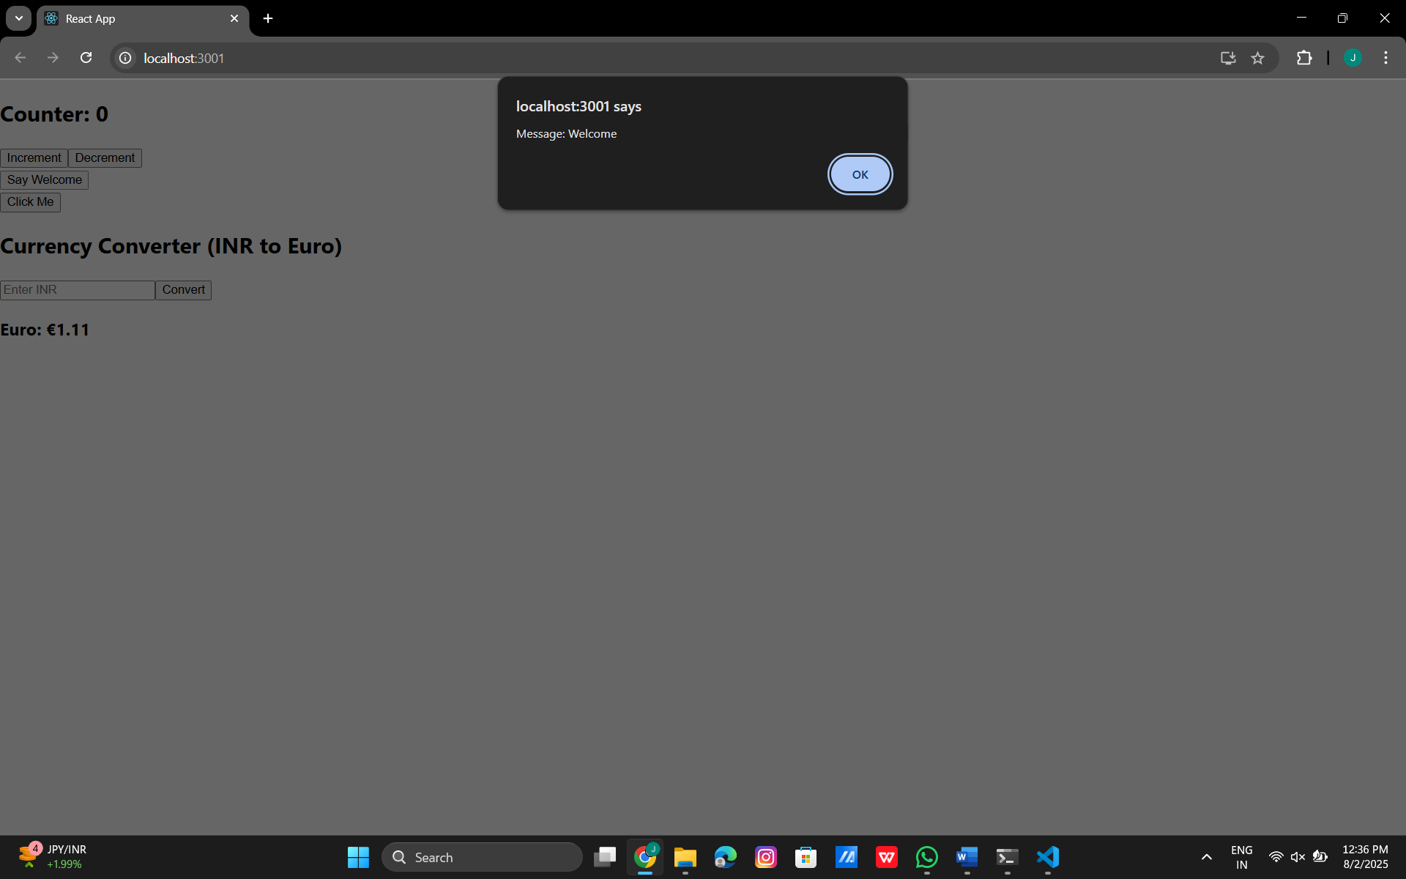
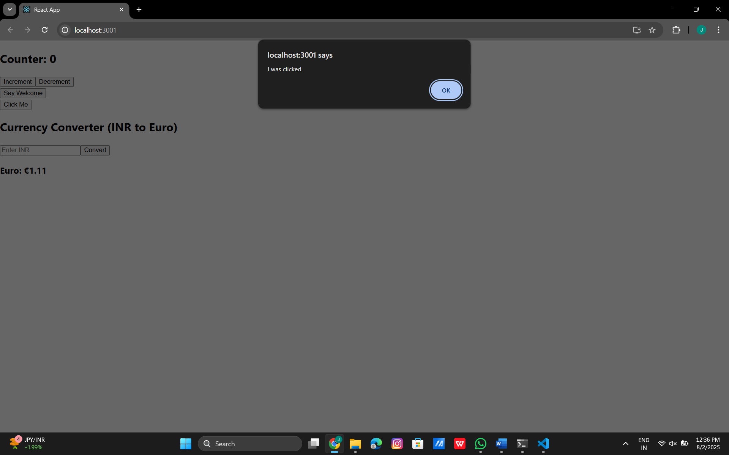
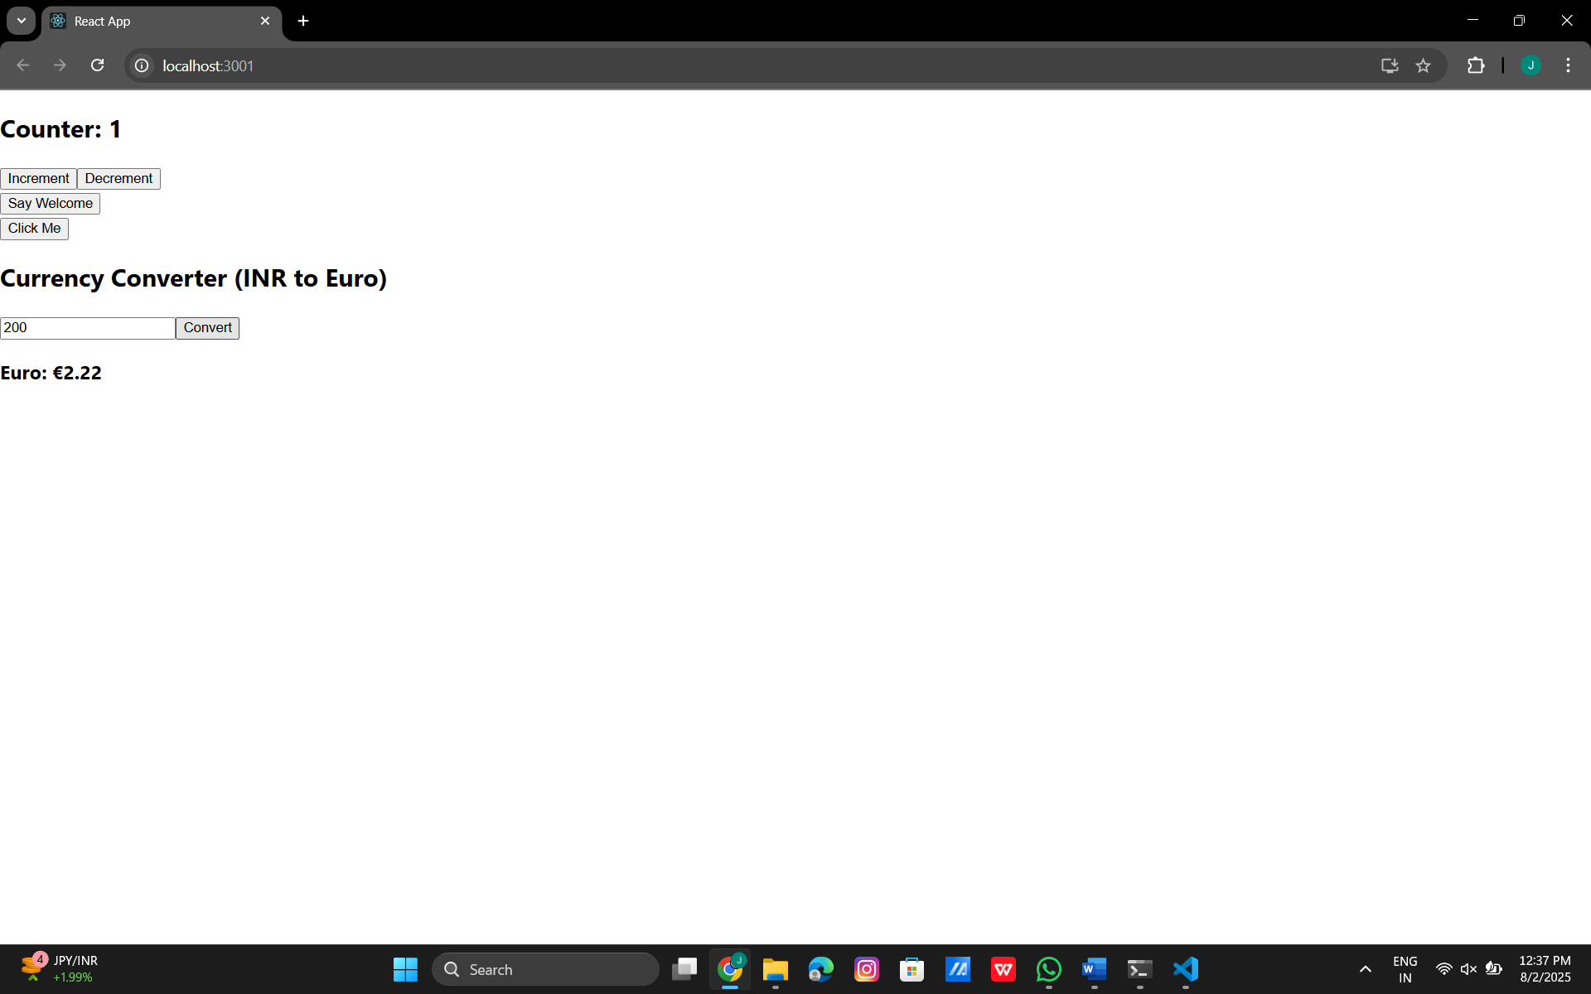
12.ReactJs
GuestPage.js:
import React from 'react';
function GuestPage() {
return (
<div>
<h2>Welcome Guest!</h2>
<p>View available flights here.</p>
</div>
);
}
export default GuestPage;
UserPage.js:
import React from 'react';
function UserPage() {
return (
<div>
<h2>Welcome User!</h2>
<p>You can now book your tickets.</p>
</div>
);
}
export default UserPage;

App.js:
import React, { useState } from 'react';
import GuestPage from './GuestPage';
import UserPage from './UserPage';
function App() {
const [isLoggedIn, setIsLoggedIn] = useState(false);
const login = () => setIsLoggedIn(true);
const logout = () => setIsLoggedIn(false);
let content;
if (isLoggedIn) {
content = <UserPage />;
} else {
content = <GuestPage />;
}
return (
<div className="App">
<h1> Ticket Booking App</h1>
{isLoggedIn ? (
<button onClick={logout}>Logout</button>
) : (
<button onClick={login}>Login</button>
)}
{content}
</div>
);
}
export default App;
App.css:
.App {
text-align: center;
font-family: Arial, sans-serif;
margin-top: 40px;
}
h1 {
font-size: 2.5rem;
color: #003366;
}
h2 {
color: #00509e;
}
p {
font-size: 1.2rem;
margin: 10px auto;
}
button {
padding: 12px 24px;
margin: 20px;
font-size: 16px;
background-color: #007bff;
color: white;
border: none;
border-radius: 8px;
cursor: pointer;
transition: background-color 0.3s ease;
}
button:hover {
background-color: #0056b3;
}
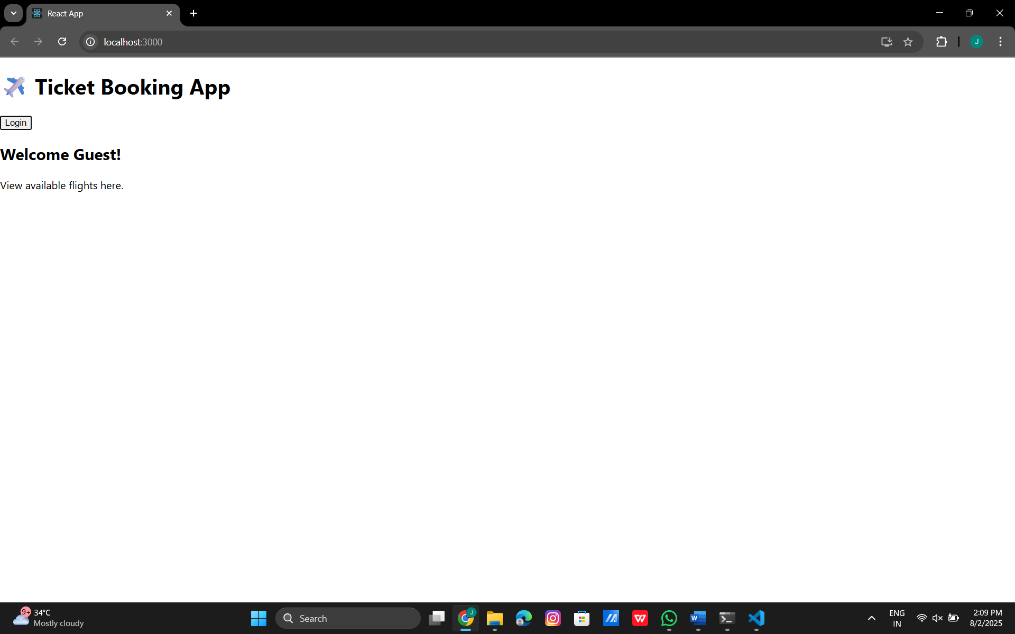

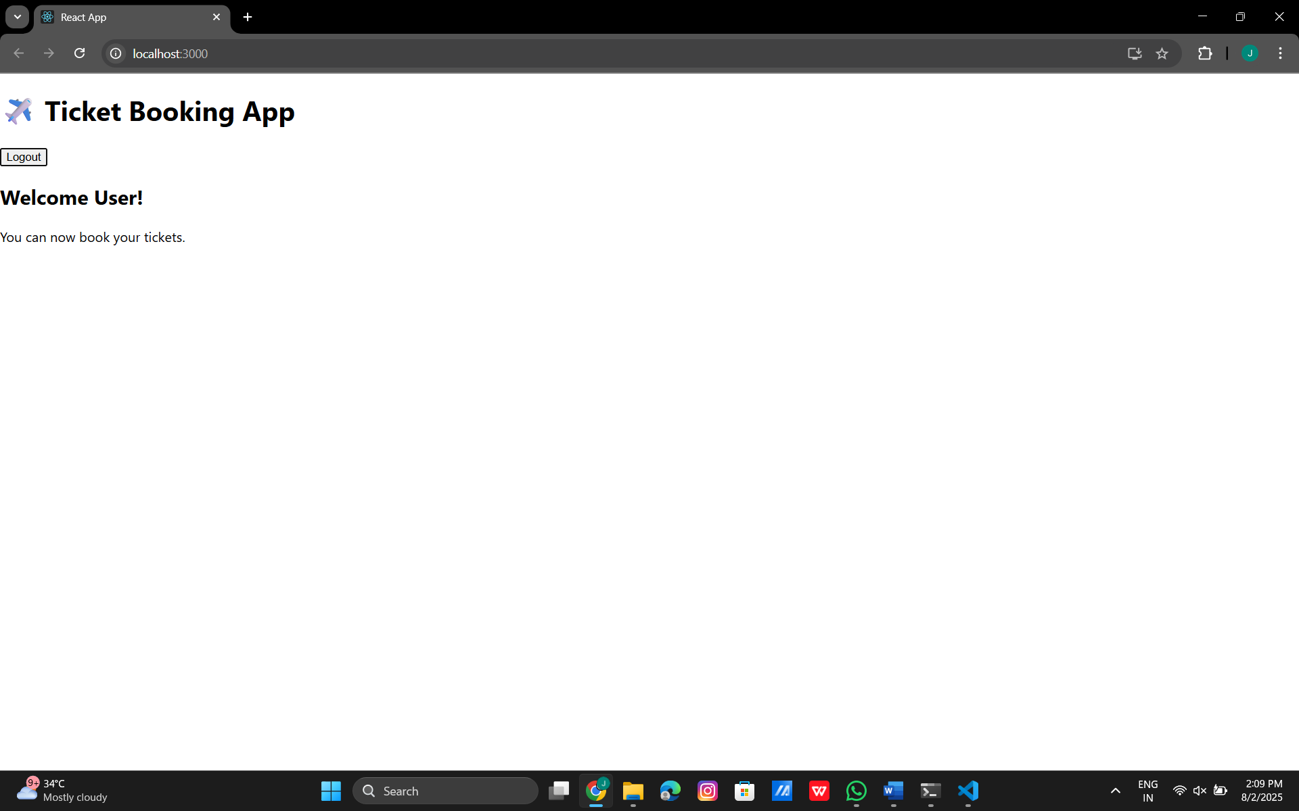
13.ReactJs
BookDetails.js:
import React from 'react';
function BookDetails() {
const books = [
{ title: 'Master React', price: '670' },
{ title: 'Deep Dive into Angular 11', price: '800' },
{ title: 'Mongo Essentials', price: '450' }
];
return (
<div className="column">
<h2>Book Details</h2>
<table>
<tbody>
{books.map((book, index) => (
<tr key={index}>
<td><strong>{book.title}</strong></td>
<td>{book.price}</td>
</tr>
))}
</tbody>
</table>
</div>
);
}
export default BookDetails;
BlogDetails.js:
import React from 'react';
function BlogDetails() {
const blogs = [
{
title: 'React Learning',
author: 'Stephen Biz',
description: 'Welcome to learning React!'
},
{
title: 'Installation',
author: 'Schwezdenier',
description: 'You can install React from npm.'
}
];
return (
<div className="column">
<h2>Blog Details</h2>
<table>
<tbody>
{blogs.map((blog, index) => (
<tr key={index}>
<td>
<strong>{blog.title}</strong><br />
<strong>{blog.author}</strong><br />
{blog.description}
</td>
</tr>
))}
</tbody>
</table>
</div>
);
}
export default BlogDetails;
CourseDetails.js:
import React from 'react';
function CourseDetails() {
const courses = [
{ name: 'Angular', date: '4/5/2021' },
{ name: 'React', date: '6/3/2021' },
];
return (
<div>
<h2>Course Details</h2>
{courses.map((course, index) => (
<p key={index}>
<strong>{course.name}</strong> {course.date}
</p>
))}
</div>
);
}
export default CourseDetails;
App.js:
import React from 'react';
import CourseDetails from './CourseDetails';
import BookDetails from './BookDetails';
import BlogDetails from './BlogDetails';
import './App.css'; // Link CSS
function App() {
return (
<div className="App">
<h1>Welcome to BloggerApp</h1>
<div className="container">
<CourseDetails />
<BookDetails />
<BlogDetails />
</div>
</div>
);
}
export default App;
App.css:
.App {
text-align: center;
}
.container {
display: flex;
justify-content: space-around; /* space between columns */
align-items: flex-start; /* align items at top */
margin: 20px;
}
.container > div {
width: 30%; /* each component takes 30% width */
padding: 10px;
border: 1px solid #ccc;
border-radius: 8px;
box-shadow: 2px 2px 5px rgba(0,0,0,0.1);
}

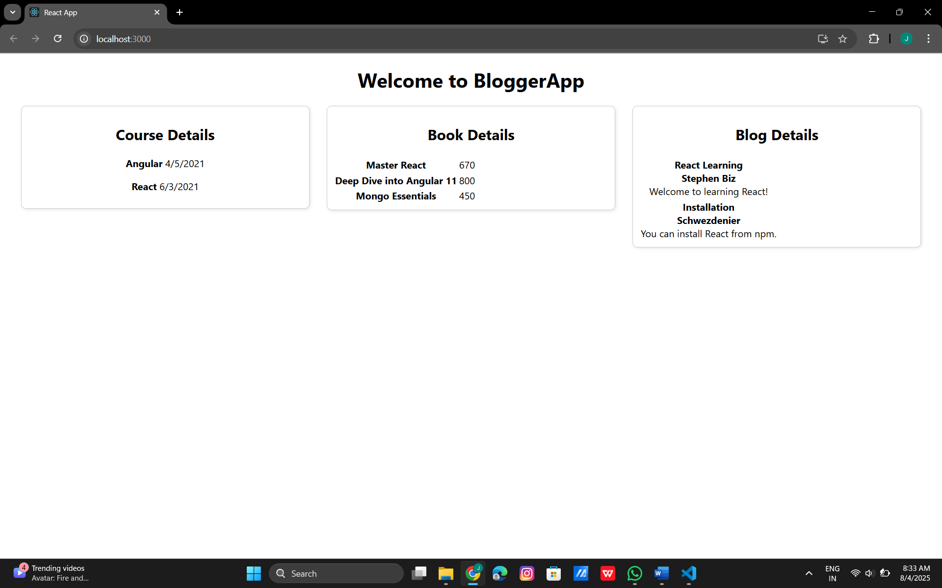

14.ReactJs
App.js:
// src/App.js
import React, { useState } from 'react';
import EmployeesList from './EmployeesList';
import ThemeContext from './ThemeContext';
import './App.css'; // Make sure this is imported
function App() {
const [theme, setTheme] = useState('light'); // default is light theme
// Toggle function
const toggleTheme = () => {
setTheme((prevTheme) => (prevTheme === 'light' ? 'dark' : 'light'));
};
return (
<ThemeContext.Provider value={theme}>
<div>
<h1>Employee Management App</h1>
{/* Theme Toggle Button */}
<button onClick={toggleTheme} style={{ marginBottom: '20px' }}>
Switch to {theme === 'light' ? 'Dark' : 'Light'} Theme
</button>
<EmployeesList />
</div>
</ThemeContext.Provider>
);
}
export default App;
EmployeesList.js:
// src/EmployeesList.js
import React from 'react';
import EmployeeCard from './EmployeeCard';
const employeeData = [
{ id: 1, name: 'John Doe', role: 'Developer' },
{ id: 2, name: 'Jane Smith', role: 'Designer' },
{ id: 3, name: 'Alice Johnson', role: 'Manager' },
];
function EmployeesList() {
return (
<div>
{employeeData.map((employee) => (
<EmployeeCard key={employee.id} employee={employee} />
))}
</div>
);
}

export default EmployeesList;
EmployeeCard.js:
// src/EmployeeCard.js
import React, { useContext } from 'react';
import ThemeContext from './ThemeContext';
function EmployeeCard({ employee }) {
const theme = useContext(ThemeContext); // get theme from context
return (
<div style={{ border: '1px solid gray', margin: '10px', padding: '10px' }}>
<h2>{employee.name}</h2>
<p>{employee.role}</p>
<button className={theme === 'dark' ? 'btn-dark' : 'btn-light'}>
View Profile
</button>
</div>
);
}
export default EmployeeCard;
App.css:
/* App.css */
.btn-light {
background-color: white;
color: black;
border: 1px solid black;
padding: 5px 10px;
cursor: pointer;
}
.btn-dark {
background-color: black;
color: white;
border: 1px solid white;
padding: 5px 10px;
cursor: pointer;
}
ThemeContext.js:
// src/ThemeContext.js
import React from 'react';
const ThemeContext = React.createContext('light'); // default value
export default ThemeContext;

Light Theme:
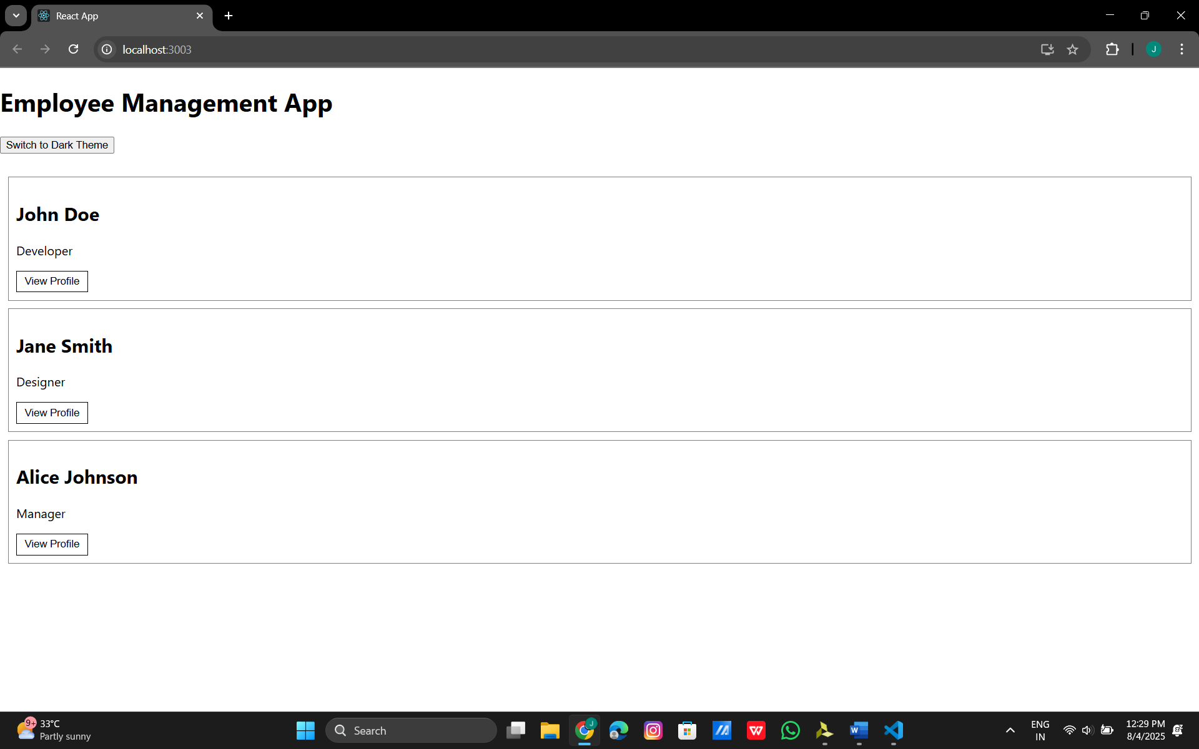
Dark Theme:
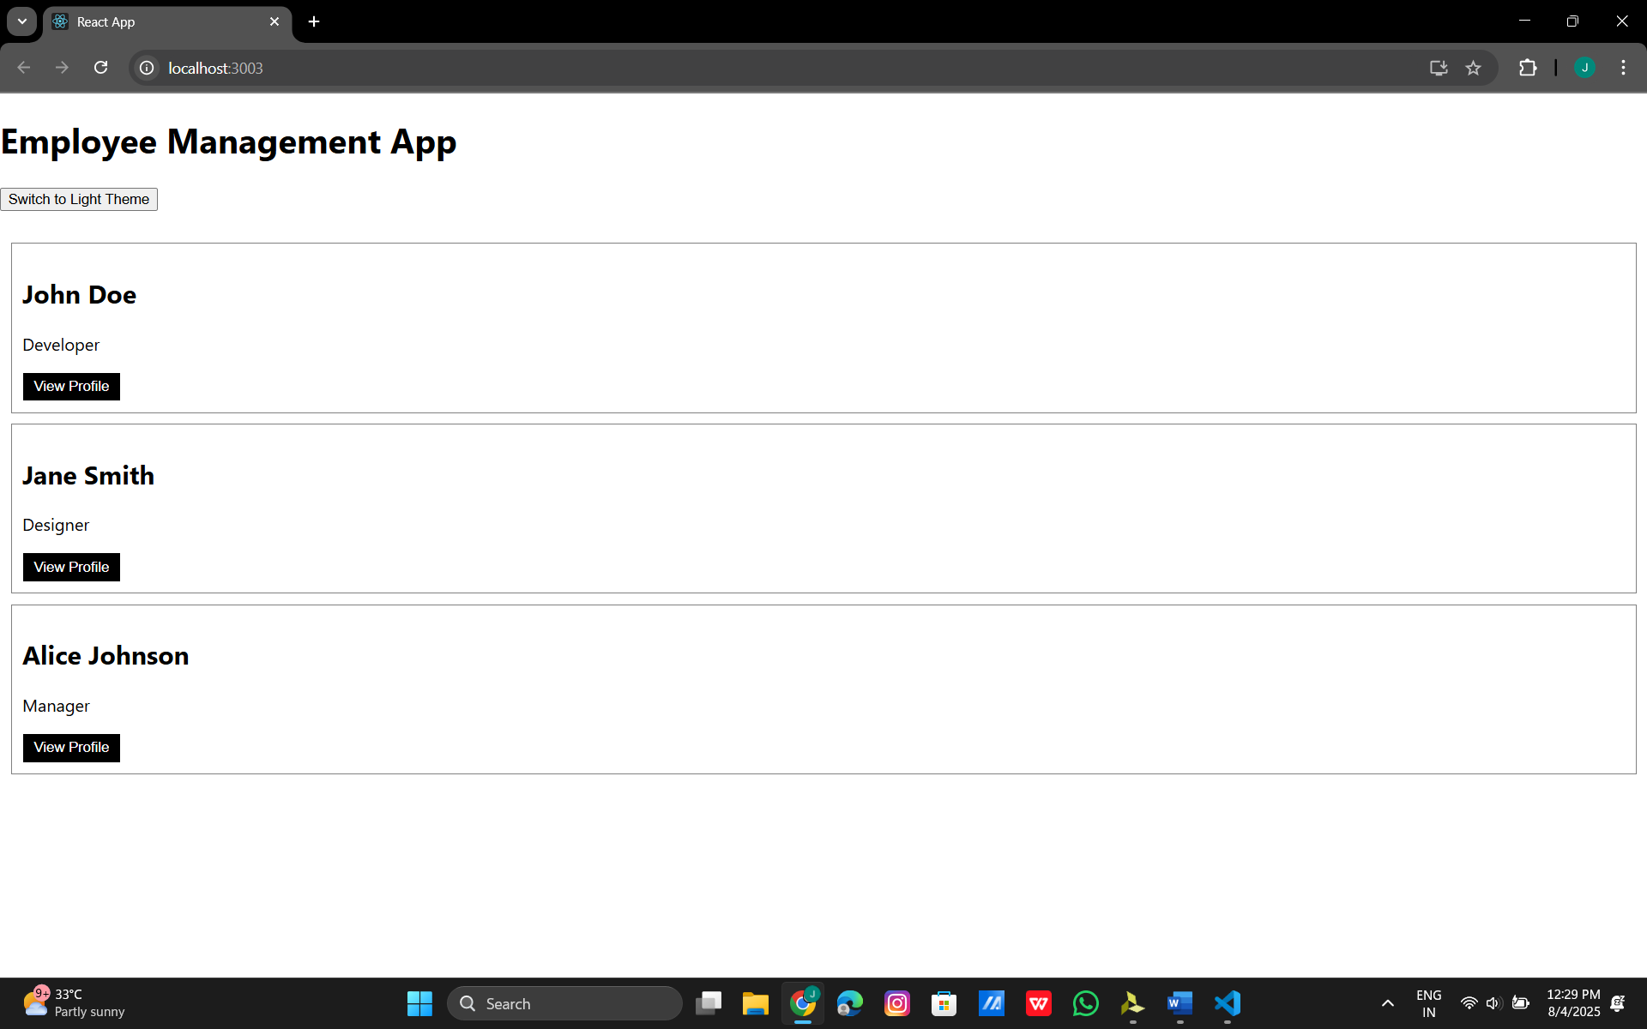

15.ReactJs
ComplaintRegister.js:
import React, { useState } from 'react';
function ComplaintRegister() {
const [employeeName, setEmployeeName] = useState('');
const [complaint, setComplaint] = useState('');
const handleSubmit = (e) => {
e.preventDefault();
// Generate a random 6-digit reference number
const referenceNumber = Math.floor(100000 + Math.random() * 900000);
alert(
`Complaint submitted successfully!\nEmployee: ${employeeName}\nReference No: ${referenceNumber}`
);
// Reset form
setEmployeeName('');
setComplaint('');
};
return (
<div style={{ margin: '50px' }}>
<h2>Raise a Complaint</h2>
<form onSubmit={handleSubmit}>
<div>
<label>Employee Name:</label>
<input
type="text"
value={employeeName}
onChange={(e) => setEmployeeName(e.target.value)}
required
/>
</div>
<div style={{ marginTop: '10px' }}>
<label>Complaint:</label>
<br />
<textarea
rows="4"
cols="50"
value={complaint}
onChange={(e) => setComplaint(e.target.value)}
required
></textarea>
</div>
<div style={{ marginTop: '10px' }}>
<button type="submit">Submit Complaint</button>
</div>
</form>
</div>
);
}
export default ComplaintRegister;
App.js:
import React from 'react';
import ComplaintRegister from './ComplaintRegister';
function App() {
return (
<div className="App">
<ComplaintRegister />
</div>
);
}
export default App;

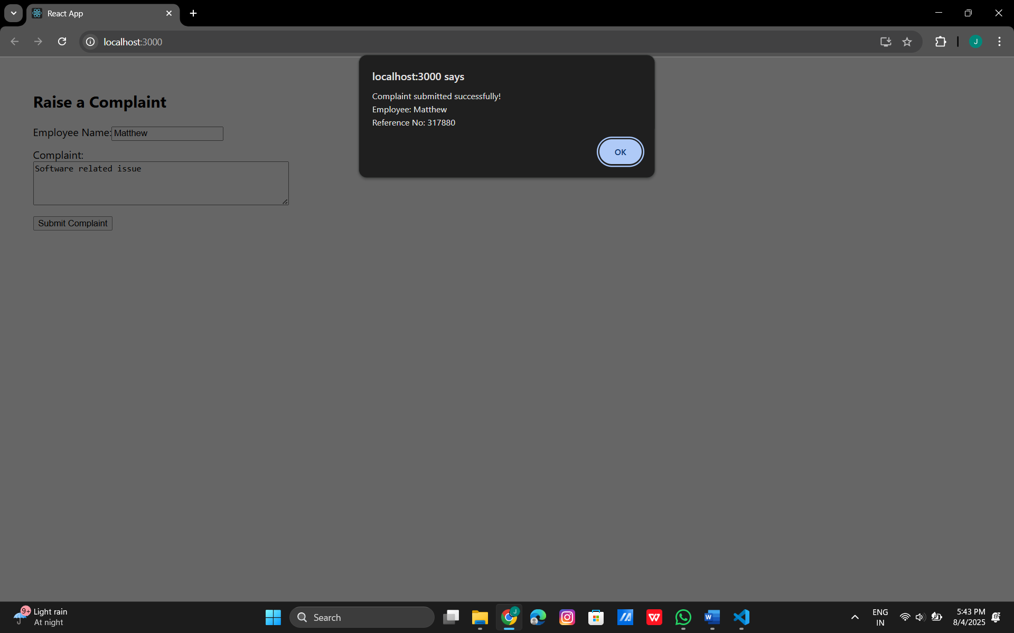

16.ReactJs
Register.js:
import React, { useState } from 'react';
function Register() {
const [formData, setFormData] = useState({
name: '',
email: '',
password: ''
});
const [errors, setErrors] = useState({});
const validate = () => {
const newErrors = {};
if (formData.name.trim().length < 5) {
newErrors.name = 'Name must be at least 5 characters';
}
if (!formData.email.includes('@') || !formData.email.includes('.')) {
newErrors.email = 'Email must contain "@" and "."';
}
if (formData.password.length < 8) {
newErrors.password = 'Password must be at least 8 characters';
}
setErrors(newErrors);
return Object.keys(newErrors).length === 0;
};
const handleChange = (e) => {
setFormData({
...formData,
[e.target.name]: e.target.value
});
};
const handleSubmit = (e) => {
e.preventDefault();
if (validate()) {
alert('Form submitted successfully!\n' +
`Name: ${formData.name}\nEmail: ${formData.email}`);
setFormData({ name: '', email: '', password: '' });
setErrors({});
}
};
return (
<div style={{ margin: '50px' }}>
<h2>Register</h2>
<form onSubmit={handleSubmit}>
<div>
<label>Name: </label><br />
<input
type="text"
name="name"
value={formData.name}
onChange={handleChange}
required
/>
{errors.name && <p style={{ color: 'red' }}>{errors.name}</p>}
</div>
<div>
<label>Email: </label><br />
<input
type="email"
name="email"
value={formData.email}
onChange={handleChange}
required
/>
{errors.email && <p style={{ color: 'red' }}>{errors.email}</p>}
</div>
<div>
<label>Password: </label><br />
<input
type="password"
name="password"
value={formData.password}
onChange={handleChange}
required
/>
{errors.password && <p style={{ color: 'red' }}>{errors.password}</p>}
</div>
<button type="submit" style={{ marginTop: '10px' }}>Register</button>
</form>
</div>
);
}
export default Register;
App.js:
import React from 'react';
import Register from './register';
function App() {
return (
<div className="App">
<Register />
</div>
);
}
export default App;
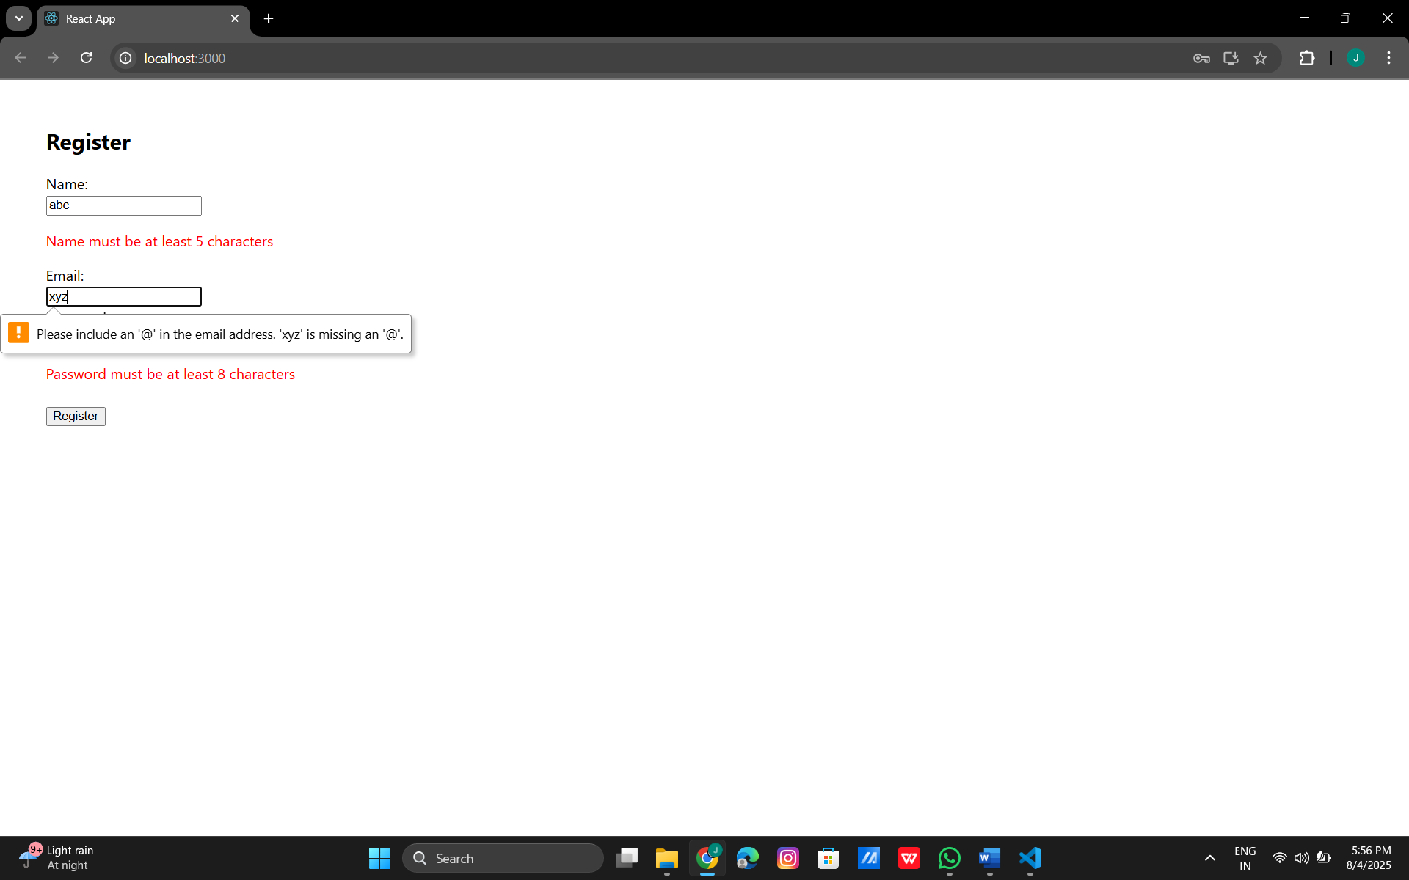

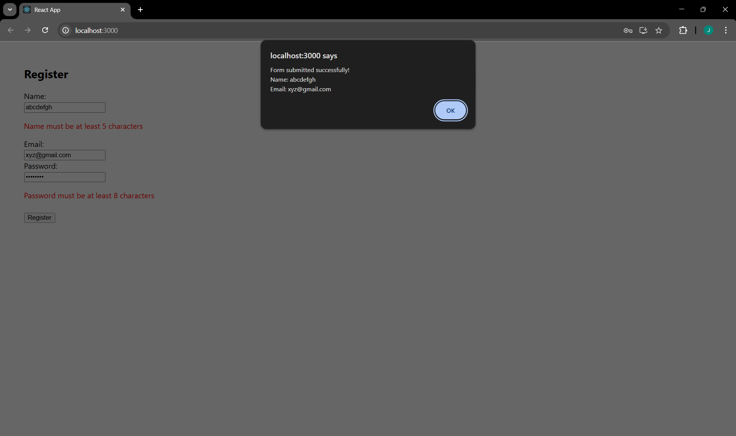

17.ReactJs
GetUser.js:
import React, { Component } from 'react';
class GetUser extends Component {
constructor() {
super();
this.state = {
user: null,
};
}
componentDidMount() {
fetch('https://api.randomuser.me/')
.then((res) => res.json())
.then((data) => {
this.setState({ user: data.results[0] });
});
}
render() {
const { user } = this.state;
return (
<div style={{ margin: '40px' }}>
<h2>Random User Details</h2>
{user ? (
<div>
<p>Title: {user.name.title}</p>
<p>First Name: {user.name.first}</p>
<img src={user.picture.large} alt="User" />
</div>
) : (
<p>Loading...</p>
)}
</div>
);
}
}
export default GetUser;
App.js:
import React from 'react';
import GetUser from './GetUser'; // U is uppercase to match the file name
function App() {
return (
<div className="App">
<GetUser />
</div>
);
}
export default App;

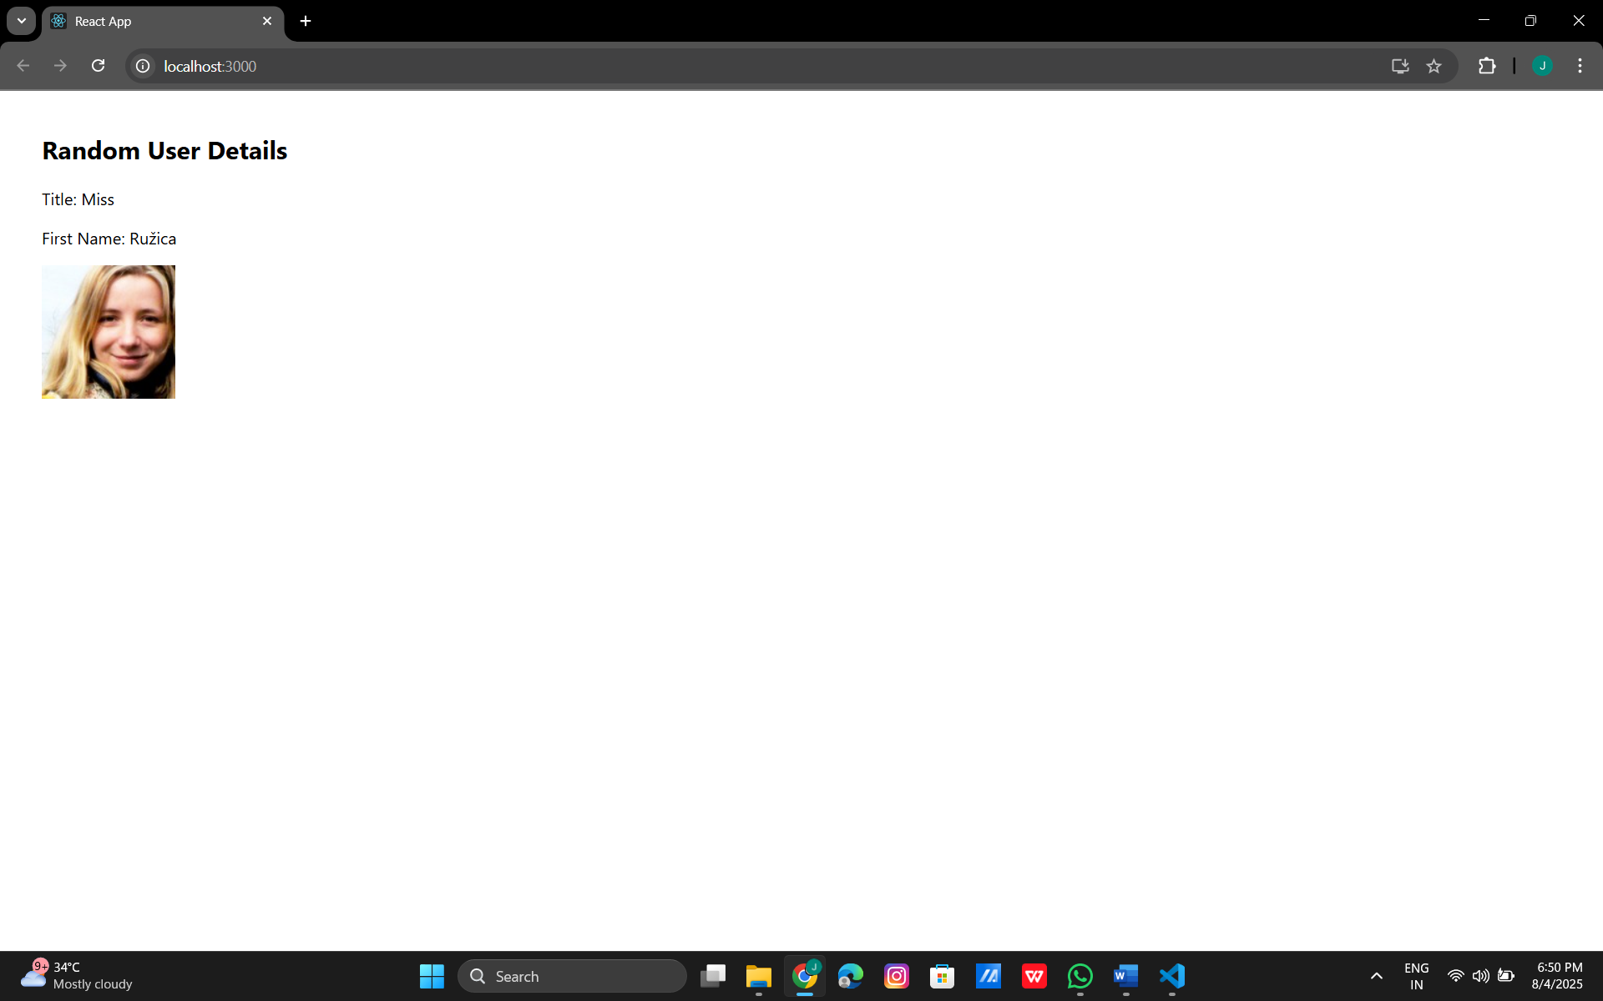

19.ReactJs
GitClient.js:
import axios from 'axios';
class GitClient {
async getRepositories(user) {
let res = await axios.get(`https://api.github.com/users/${user}/repos`);
return res.data.map(r => r.name);
}
}
export default GitClient;
App.js:
import React, { useState, useEffect } from 'react';
import GitClient from './GitClient';
function App() {
const [repos, setRepos] = useState([]);
useEffect(() => {
new GitClient().getRepositories('techiesyed')
.then(data => setRepos(data));
}, []);
return (
<div>
<h2>Repositories</h2>
<ul>
{repos.map(r => <li key={r}>{r}</li>)}
</ul>
</div>
);
}
export default App;
